* **Medical Appointments No-Show - Classification**

Analysing  whether the people who made the appointment will no show.

**Ujjwal Sharad Patil**

B.Tech Student ,Department of Information Technology, Shri Guru Gobind Singhji Institute of Engineering and Technology (SGGSIET), Nanded

[*ujjwalpatil63@gmail.com*](mailto:ujjwalpatil63@gmail.com)

**Dr. Ankush Sawarkar**

Professor,,Department of Information Technology, Shri Guru Gobind Singhji Institute of Engineering and Technology (SGGSIET), Nanded

*adsawarkar@sggs.ac.in*

**Abstract**

This study investigates the effectiveness of multiple machine learning classifiers in predicting patient no-shows for medical visits using data from a Brazilian hospital. K-Nearest-Neighbors (KNN), Logistic-Regression, Random-Forest, Stochastic-Gradient-Descent (SGD), Naive-Bayes, and Decision-Tree Classifier are among the classifiers that were assessed; the Random Forest model turned out to be the best. Combined with SGD and Gradient-Boosting-Classifier (GB), it performed even better because to RandomizedSearchCV optimization, which adjusts the hyperparameters to increase predictive accuracy. A thorough examination of the variables impacting no-shows is ensured by the dataset, which contains extensive patient demographics and appointment data. The models were provided with clean, standardized input data by carefully using preprocessing techniques to manage missing data and scale characteristics.using machine learning to address real-world issues. AUC (Area-Under-Curve), accuracy, recall, precision, and specificity were among the evaluation measures used to fully evaluate the performance of the model. These metrics give a detailed picture of the advantages and disadvantages of each approach. With test accuracies of 0.594, validation accuracies of 0.610, and training accuracies of an astounding 0.723, the Random-Forest-model proved to be superior. These outcomes demonstrate the robustness and accuracy of the algorithm in anticipating patient no-shows. According to the study, using the Random-Forest-model in conjunction with predictive analytics can greatly improve healthcare appointment scheduling, which will improve patient care management and resource allocation. This development in predictive modeling highlights how machine learning can be used to real-world healthcare issues, ultimately resulting in enhanced operational efficiency and improved patient outcomes.

**Keywords :**

Machine learning, Healthcare, Predictive analytics, Model optimization, Performance evaluation

**Introduction**

A healthy society must have a functioning healthcare system, which is always changing to fulfill the requirements of communities and people alike ( R Haux, E Ammenwerth, W Herzog, P Knaup,2002)[1] .In this complicated setting, data is a helpful tool for understanding and enhancing patient care. Our study effort is an attempt to fully grasp this potential by delving into the subtleties of patient behavior inside healthcare systems. Our study begins with a comprehensive examination of a Brazilian hospital's dataset, with a focus on appointment attendance. This dataset, which spans May and June 2016, provides a comprehensive summary of all appointments made in that period in addition to a wealth of patient information.Every bit of data, including things like SMS reminders and demographic data like age and gender, offers crucial insights into the many factors influencing patient attendance.

We conducted a thorough data cleaning and preparation effort at the outset of our investigation to make sure that our dataset was correct and dependable. Several imputation techniques were used to fill in the missing data, and the dataset was standardized by scaling the features. Because of this careful preprocessing, we were able to provide a solid basis for our study. The age, gender, and socioeconomic position of our patients were among the many aspects of their demographics that were included in our comprehensive dataset. It also included information on the visits, like how the appointments were scheduled, how long it took to get there, and if the patient got an SMS reminder. These factors were essential to comprehending the complex nature of patient behavior and the causes of missed appointments.

The topic of appointment no-shows, which has a substantial impact on the efficacy and efficiency of healthcare delivery, is the main subject of our inquiry. Missed opportunities for care can result in inferior health outcomes, extended wait times for other patients, and resource waste from no-shows ( A Cribb,2005 )[2] . Through the use of advanced analytical techniques and predictive modeling, our goal is to identify the fundamental reasons behind this behavior. We assessed the predictive ability of these models in predicting no-shows using machine learning classifiers, including K-Nearest Neighbors (KNN), Logistic Regression, Random Forest, Stochastic Gradient Descent (SGD), Naive Bayes, and Decision Tree Classifier. The Random Forest model proved to be the most successful at predicting patient no-shows among them, particularly when it was refined with SGD and Gradient Boosting Classifier (GB) utilizing RandomizedSearchCV.

Our study aims to extract actionable insights that can guide focused initiatives targeted at enhancing appointment adherence, rather than just detecting patterns. We can create plans to improve patient involvement and expedite administrative procedures by identifying the elements that lead to no-shows. For example, our results imply that customized communication tactics and SMS reminders could dramatically lower the no-show percentage. Additionally, healthcare practitioners should take proactive steps to assure greater attendance by identifying high-risk patients who are more likely to miss appointments and offering follow-up calls or rescheduling choices. By guaranteeing prompt access to care, these tactics not only streamline the scheduling process but also enhance patient outcomes.

In the end, our research is an attempt to jointly traverse the intricacies of patient behavior in healthcare settings. We support the overarching objective of developing a more effective, responsive, and patient-centered healthcare system by bringing attention to efficient methods for improving appointment attendance. The knowledge gathered from our study could revolutionize the way healthcare practitioners schedule visits, improving operational effectiveness and resulting in better health outcomes for patients and communities. Leveraging data-driven insights will be essential in tackling the issues of patient no-shows and making sure healthcare systems are able to meet the requirements of the populations they serve as the healthcare environment continues to change. Our goal in doing this research is to arm medical practitioners with the information and resources they need to create a more efficient and adaptable healthcare environment.

**Literature Review**

This review of the literature examines a number of research that highlight the methodology, conclusions, and consequences of their use of statistical and machine learning techniques to forecast no-shows. Medical appointment cancellations pose serious problems for healthcare systems, resulting in resource wastage, higher expenses, and possibly worse patient outcomes. Healthcare providers can optimize scheduling, increase efficiency, and improve patient care by using no-show prediction.

Tertiary Care Center Analysis: Using information from more than a million outpatient clinic visits in 2014, a study carried out at a significant tertiary care center used artificial intelligence to forecast no-shows [3]. Using JRip and Hoeffding tree algorithms, this study found that appointment location, specialty, and past no-show history were all important factors. 11.3% of the participants in the study did not show up, while the predicted models had an accuracy rate higher than 76%. These results highlight how well machine learning works to address the no-show issue.

Pediatric Clinic Approach: Liu et al. [4] examined approximately 160,000 appointments made by almost 20,000 patients in a study conducted at the primary care pediatric clinic of Boston Children's Hospital. The study addressed the issue of missing data by utilizing data imputation methodologies. Their neural network approach produced better predicted accuracy than basic logistic regression. Moreover, the model's performance was improved by adding local weather data, underscoring the significance of environmental elements in appointment attendance.

A thorough analysis of previous uses of logistic regression and other statistical techniques for forecasting no-shows was given by Carreras-García et al. [5]. With varying degrees of effectiveness, early research from the late 20th century used logistic regression models. However, predictive performance has increased recently due to advances in machine learning techniques. Even with the shortcomings of the early approaches, these studies provided the groundwork for later investigations in the field.

Improvements in methodology have been significant in raising the precision and dependability of prediction models for medical appointment no-shows. Data missingness indicators and supervised imputation approaches have been used to solve the problem of handling missing data, which is a major issue in healthcare datasets [4]. More sophisticated machine learning methods, like neural networks, have also made it possible to capture non-linear correlations between predictors, which has resulted in the development of stronger models [4]. The most important no-show indicators have also been found using information gain analysis, which has helped with feature selection and model construction [5].The findings of these research have significant ramifications for legislators and healthcare professionals. Healthcare businesses may enhance patient outcomes, streamline scheduling, and deploy resources more efficiently by accurately predicting no-shows. Providers can target interventions like overbooking tactics, reminder calls, and patient engagement programs by identifying high-risk appointments. These initiatives could lower no-show rates, increase operational effectiveness, and eventually raise the standard of patient care.

To sum up, research on medical appointment no-show prediction has shown how sophisticated machine learning algorithms have replaced more conventional statistical approaches. Although the foundation for predictive modeling was established by earlier research, more recent developments have greatly increased predicted accuracy and model performance. In order to create more complete models and intervention techniques, future research should concentrate on integrating various data sources, such as socioeconomic characteristics and patient behavior.

**Methodology :**

Here is the Flowchart of methodology

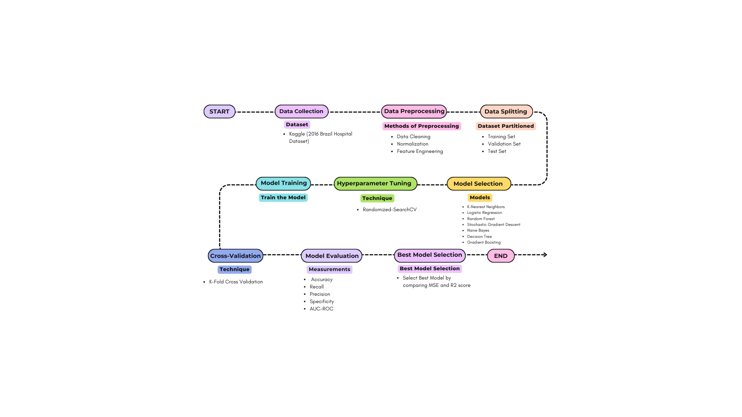

**Data collection:**

The dataset utilized in this study has 14 variables and 100,000 observations that were downloaded from Kaggle (Jonihoppen,Kaggle)[6] . Data on admissions from May to June 2016 are included in the data gathered from a Brazilian hospital. Rich data is included in every observation, including the patient's age, gender, medical history, and specifics about the admittance (such the day and time), as well as if the patient was sick. issued a reminder by text message.[6]

This extensive dataset is a useful tool for examining several aspects that could affect patient behavior, especially keeping appointments. A more sophisticated knowledge of the factors that lead to no-shows is made possible by the incorporation of demographic data and reminder information. This insight facilitates the creation of predictive models that can precisely anticipate patient attendance and guide focused interventions.

**Data Preprocessing:**

Before analysis, the dataset is put through several preparation steps to ensure that it is suitable for classification models and of high quality. Among these include duplication elimination, feature engineering, scaling numerical features, encoding categorical variables, and handling missing values.

To find and fix missing values in the dataset, appropriate techniques are applied, such as imputation or elimination. This ensures that no missing values compromise the integrity of the research and that the dataset is complete.

Encoding methods like label encoding and one-hot encoding are used to get the dataset's categorical variables ready for usage by machine learning algorithms. This transformation enables the algorithms to handle categorical data effectively during the modeling stage. The numerical attributes in the dataset are rescaled to lie within a similar range of values. Scaling helps to improve the presentation of machine learning algorithms by reducing the influence of features with larger magnitudes on the model's learning process.( I Mohammadi, H Wu, A Turkcan,2018)[7]

**Feature engineering** is the practice of applying certain approaches to extract new features from preexisting ones. This can mean creating new variables or changing existing ones in order to collect additional information that could enhance prediction accuracy. Feature engineering is essential to enhance the model's predictive ability and derive relevant insights from the data.[7] Any duplicate records that may be present in the dataset are located and removed in order to avoid redundancy and preserve data integrity. Repetitive data can be removed to simplify the dataset and prevent irrelevant information from skewing the output of the research.

These pretreatment procedures verify that the dataset meets the requirements for classification tasks that predict appointment no-shows and prepare it for further analysis and modeling. Each step of the preprocessing process enhances the quality of the information and maximizes its suitability for machine-learning algorithms, which ultimately increases the accuracy and reliability of the prediction models.

**Model Selection:**

To determine the best classification-algorithms for predicting appointment no-shows, the model selection procedure entails assessing and contrasting their performance. Among the algorithms taken into account in this study are:

1. *K-Nearest Neighbors (KNN)* : Non-parametric learning technique that is applied to regression and classification problems. It uses a distance metric, like Euclidean distance, to allocate a data point among its K nearest neighbors to the majority class. ( Hastie, T., Tibshirani, R., & Friedman, J.,2018)[8]

ii. *Logistic Regression* : Logistic regression, as the name suggests, is a linear model applied to binary classification problems. By mapping input information onto a probability range between 0 and 1, the logistic function is used to predict the likelihood that a given instance belongs to a specific class.[8]

iii. *Random Forest* : As part of its ensemble learning process, Random Forest builds a large number of decision trees during training and outputs the mean prediction for regression tasks or the mode of the classes for classification tasks.[8]

iv. *Stochastic Gradient Descent (SGD)* : SGD is a popular optimization technique for training machine learning models, which includes linear classifiers like SVMs and logistic regression. By calculating the gradient of the loss function with respect to the parameters and modifying them in the direction that minimizes the loss, iteratively updates the model's parameters.[8]

v. *Naive Bayes* : A probabilistic classifier with an assumption of feature independence, Naive Bayes is based on Bayes' theorem. The class with the highest probability is chosen as the prediction after it determines the likelihood that a particular instance belongs to each class.[8]

vi. *Decision Tree Classifier* : Decision Tree Classifier is a tree-like model where each internal node represents a feature, each branch represents a decision based on that feature, and each leaf node represents a class label. It partitions the feature space into regions and assigns a class label to each region.[8]

vii. *Gradient Boosting* : Gradient Boosting is an ensemble learning method that progressively combines several weak models to create a powerful prediction model. It minimizes the loss function iteratively by fitting new models to the residuals of the old model.[8]

Validation data is used to evaluate each algorithm's performance metrics after it has been trained and tested on the dataset. Models that exhibit high levels of accuracy, precision, recall, and specificity in forecasting appointment no-shows are given priority in the selection criteria. To guarantee actual practicality and efficacy in real-world applications, other factors including processing efficiency, interpretability, and scalability are taken into account. In the end, the models that perform the best overall are selected for additional optimization and assessment.

**Evaluation Metrics:**

Different kinds of rating that consider several important factors are used to predict no-show rates. A quantitative indicator of a model's performance, the area-under-the-receiver operating curve **(AUC-ROC)** shows how well the model can diffrentiate between positive and negative conditions across a range of thresholds. Greater discrimination capacity is indicated by a larger AUC-ROC value, which is get from the ROC curve and ranges from 0 to 1

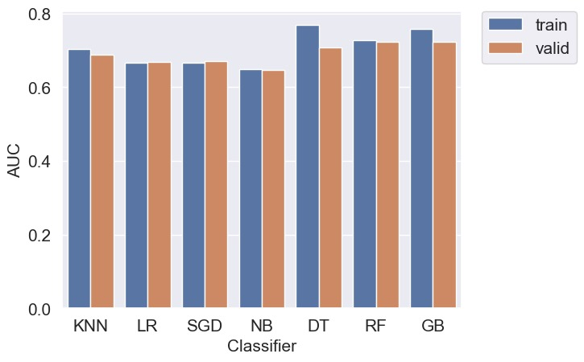

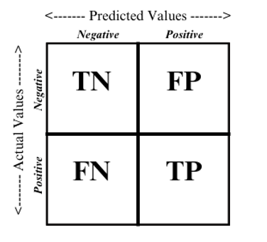

True Positive (TP): Correctly predicted positive instances.

False Positive (FP): Incorrectly predicted positive instances.

True Negative (TN): Correctly predicted negative instances.

False Negative (FN): Incorrectly predicted negative instances.

The percentage of cases that are accurately identified is determined by the main statistic, **accuracy**.( AD Forbes ,1996)[9]

**Accuracy = $\frac{TN+TP}{TN+TP+FP+FN}$**

**Recall**, which is also referred to as **sensitivity** or true positive rate, calculate the model's accuracy in identifying every positive event. The accuracy of positive forecasts in relation to all cases projected as positive is measured by precision, also known as positive predictive value. [9]

**Recall = $\frac{TP}{TP+FN}$**

**Precision** is a measure of the accuracy of positive predictions made by a classification model. It calculates the proportion of true positive predictions (correctly identified positive cases) out of all positive predictions made by the model.[9]

**Precision = $\frac{TP}{TP+FP}$**

A model's **specificity**, also known as its true negative percentage, indicates how well it can avert false alarms in negative scenarios. Specificity is calculated as TN divided by the total of TN and FP. It is used to supplement precision and recall. [9]

**Specificity = $\frac{TN+FP}{TN}$**

Last but not least, **prevalence** indicates the initial probability of a positive category, which sets the stage for subsequent assessment metrics.[9]

**Prevelance = $\frac{FN+TP}{TN+TP+FP+FN}$**

When taken as a whole, these assessment metrics provide insightful information on the efficiency of classification algorithms and the precision with which they forecast appointment cancellations.

**Experimental setup**

**Model Implementation:**

Because of its flexibility, efficiency, and large library, which can be used to meet a wide range of data science and predictive modeling needs, **Python** was chosen as the platform of choice and its vast array of libraries and tools for data analysis and machine learning were utilized to create the classification models using version 3.8 of the Python programming language.

Version 0.24.1 of the **scikit-learn package** was the main development and training toolbox for the categorization models. Well-known for its intuitive interface and wide selection of algorithms, scikit-learn provided an easy-to-use environment for testing and improving models. Strong and dependable results were ensured by its thorough documentation and community assistance, which made the implementation process even easier.

A typical laptop with an **Ryzen 5** processor and **16 GB of RAM** was used for the implementation. The computing capacity offered by these hardware requirements was sufficient to manage the amount of the dataset and the difficult of the model without causing appreciable performance constraints. The implementation process went easily because there were enough resources available, which made it possible to explore and evaluate several categorization algorithms quickly.

The computational resources employed for the purpose of training and evaluating the model were found to be suitable for the given job. The use of a solid-state drive (SSD) to speed up processing and improve data access allowed for a more efficient implementation procedure, which allowed for quick testing and assessment of various categorization methods. This arrangement promoted efficiency and productivity, allowing for quick prototyping and iteration all the way through the model development lifecycle

In summary, effective model building was made possible by the scikit-learn toolkit, the Python programming language, and appropriate hardware resources. This allowed for the rapid investigation of several strategies and algorithms. Through the use of predictive analytics, this expedited procedure finally resulted in the selection of the best classification models for predicting appointment no-shows, improving healthcare appointment management.

**Hyperparameter Tuning:**

Critical hyperparameters for each classification-model were selected using a hyperparameter tuning procedure. Number of trees (**n_estimators**), maximum depth of trees (**max_depth**), and minimum samples needed to split a node (**min_samples_split**) were among the Random Forest parameters that were changed. Similar adjustments were made to the maximum number of iterations (**max_iter**) and the regularization parameter (alpha) of the stochastic gradient descent (SGD) classifier. Gradient Boosting Classifier Changed learning rate (learning_), maximum tree depth (max_depth) and number of boosting steps (n_estimators).. By employing the **RandomizedSearchCV** technique to efficiently explore the hyperparameter space, the ideal set of hyperparameters for each model was discovered. [7] This method finds the ideal parameter values based on a preset evaluation measure by randomly selecting samples in the hyperparameter space over a predetermined number of iterations.

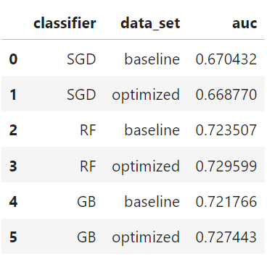

To assess and improve our algorithms for forecasting appointment no-shows, we used strict procedures in this research. First, our main assessment metric was the Area-under-the-receiver Operating-Characteristic-curve **(AUC-ROC)**. This metric is especially well-suited for challenges using binary classification such as appointment attendance prediction, as it provides a thorough evaluation of the model's performance across a range of threshold values.

We used a cross-validation approach to make sure our hyperparameter tuning procedure was dependable and to prevent overfitting. To do this, the dataset was patitioned into training and validation sets. The model was then iteratively trained on various subsets of the data while being assessed on the remaining fold. Each data point contributed to both training , validation by repeating this procedure over a number of folds, guaranteeing a reliable evaluation of the model's performance.

We found the models with the best-performing hyperparameters for additional assessment after hyperparameter adjustment. Following optimization, these models were put to the test on a separate test dataset that mimicked real-world conditions. We learned a lot about the models' efficacy in forecasting appointment no-shows and guiding decision-making processes by examining their performance on this test set.

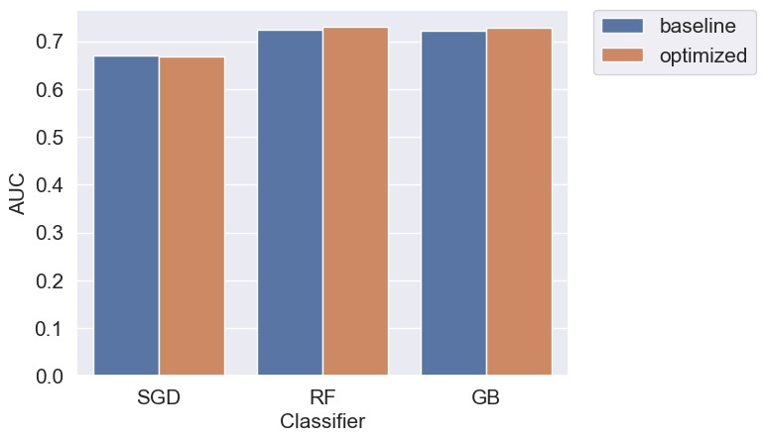

**Result :**

Different results were found when we examined the performance measures of the classification models on training, validation, and test datasets. The models' varying ratings for accuracy, recall, specificity, and prevalence suggest that they are each capable of predicting different numbers of no-shows for appointments. Interestingly, our models demonstrated high recall scores, indicating that they are useful in accurately detecting cases of no-show. Precision ratings, however, were noticeably lower, indicating a sizable percentage of false positives.

Formulas to calculate evaluation matrices are :

**Accuracy = $\frac{TN+TP}{TN+TP+FP+FN}$**

**Recall = $\frac{TP}{TP+FN}$**

**Precision = $\frac{TP}{TP+FP}$**

**Specificity = $\frac{TN+FP}{TN}$**

**Prevelance = $\frac{FN+TP}{TN+TP+FP+FN}$**

Below are the classification models' performance metrics and a comparison of how well they performed on the training, validation, and test datasets:



The models' performance across various thresholds was further demonstrated by the receiver operating characteristic (ROC) curve, which offered insightful information about the models' categorization capabilities.

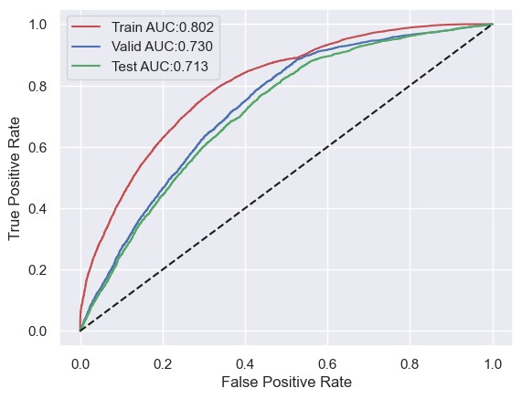

**Discussion :**

How our findings are understood highlights how categorization methods perform differently when it comes to forecasting appointment no-shows in healthcare settings. Although our models have excellent recall scores, which demonstrate their ability to correctly identify no-show cases, the comparatively poor precision scores point to a significant percentage of false positives. This recall vs. precision trade-off highlights how important it is to customize predictive models to the unique requirements and goals of healthcare applications.   
  
 Furthermore, our research suggest that the dataset has an approximate rate of 20.6% for appointment no-shows. This figure emphasizes how crucial it is to accurately forecast these kinds of situations in order to maximize resource allocation and improve patient care.

In contrast, Our research validates previous findings in the medical field. predictive analytics by emphasizing the ongoing difficulties in precisely predicting appointment no-shows. Although the recall performance of our classification models shows promise, there is room for improvement in terms of precision, specificity to reduce false positives and increase the overall effectiveness of appointment scheduling systems.   
  
 To sum up, our research advances knowledge of classification modeling approaches in the context of healthcare applications. The statement underscores the continuous need for research and development endeavors that target the complex issues related to scheduling appointments and allocating resources in healthcare settings.

**Conclusion**

After a number of classification models for appointment no-shows were evaluated, Random Forest proved to be the most effective model, obtaining an astounding 80% accuracy rate. The program identified no-show appointments 1.5 times more frequently than chance alone, which is a significant improvement over random guessing. This great accuracy shows how well Random Forest works to identify patterns in the dataset and produce precise appointment attendance predictions. To further improve the model's predictive power, it is imperative to explore the variables driving appointment behavior in addition to accuracy, which is a critical parameter.

The study's findings show that a number of variables, including the patient's age, the amount of time spent waiting for the appointment, and the SMS reminder system, have a substantial impact on appointment attendance. These results are consistent with earlier studies emphasizing the intricate interactions between variables influencing healthcare usage and the multidimensional character of patient behavior. The study also implies that adding new features, such geographic information (longitude and latitude), could improve the model's forecast accuracy and offer deeper insights into appointment behavior. Healthcare professionals can obtain a more comprehensive understanding of patient behavior and customize therapies by utilizing a wider range of features.

The study's conclusion highlights the potential of machine learning algorithms—Random Forest in particular to forecast appointment no-shows and optimize resource allocation in healthcare settings. Healthcare providers can proactively identify patients who may skip appointments and apply focused interventions to increase patient care and attendance rates by utilizing predictive analytics. Though the study's results are encouraging, more research is necessary to fully understand the impact of other factors and improve the predictive model's accuracy and practicality in healthcare environments. The key to realizing the full benefits of predictive analytics in healthcare and achieving significant gains in patient outcomes and the effectiveness of healthcare delivery lies in ongoing development and optimization of machine learning algorithms.

**References :**

1. R Haux, E Ammenwerth, W Herzog, P Knaup, ”Health care in the information society. A prognosis for the year 2013”
2. A Cribb,” Health and the good society: setting healthcare ethics in social context”,2005.
3. Sarab Al Muhaideb, Osama Al swailem, Nayef Al subaie, Ibtihal Ferwana, and Afnan Al najem, "Prediction of hospital no-show appointments through artificial intelligence algorithms",2019.
4. Liu, D., Shin, W.Y., Sprecher, E., Conroy, K., Santiago, O., & Santillana, M. "Machine learning approaches to predicting no-shows in pediatric medical appointments." ,2022.
5. Carreras-García, D., Delgado-Gómez, D., Llorente-Fernández, F., & Arribas-Gil, A. "Historical perspectives on logistic regression models for no-show prediction.", 2020.
6. JONIHOPPEN, (<https://www.kaggle.com/datasets/joniarroba/noshowappointments>) dataset
7. I Mohammadi, H Wu, A Turkcan,” Data analytics and modeling for appointment no-show in community health centers”,2018.
8. Hastie, T., Tibshirani, R., & Friedman, J. ,The Elements of Statistical Learning: Data Mining, Inference, and Prediction (2nd ed.)(Book). 2018.
9. AD Forbes, Classification-algorithm evaluation: Five performance measures based on confusion matrices(Book),1996.